**Load Balancers**

Load Balancers:

They will balance the load coming from machines. Web server/ Data server or high intense application server when application resources will increase when ever end user request uses , database transactions are high, web server request will be high, that server has to handle all request that configured RAM or CPU or storage that will use it.

That request can be handled upto max resources utilsed/ reached and at one point 100 resource will be ustilsed/ it will go peak at that time server will be exhausted.

Extra request will be in the queue and if queue is increased performance will be degraded.

End user expreince will be damaged. Web page will be loading very slow

For the same database/ webserver we are allocating the several machines

First VM is exhausted. 100% utilisation is complted. The request coming from queue will diverted to second VM and so on the process will be done. This will be handled by load balancer

Machine will moniotr the load and it does not exhaust and it has to handle the request equally ( one request to one machine and another request to another VM and so on) sequentially it will send the request. No machine has to be exhausted in this case

Independent architecture does not auto scaling possibilty we need to add it manually

On premises/ regular scenarios load balancers are hardware componets

F5 is the company that will do only load balancers

It will show like physcial device which shows like router and switches or server

With out load balancer if you assign one private ip to one url and another private Ip to the same url and when he hit ip address then web page will be opened. However, user has to remember the ip address which is not goot practise and also we are exposing the ips to public

With common Ip and same machine handled as single entity will do by load balancer

We will configure domain name and public ip in the load balancer

A request from end user will first hit by load balancer that load balancer will take that request and forward to respective instances

In the networking if the communication has to be happen from one sytem to another syetm there are some rules that rules are called protocals

If our laptap is accessing the one website for accessing it we have some rules it has use browser, that website has to run on the http again http has some rules.

RDP has some protacls

All protocals present in networking is defined in OSI Model.

It is actually defined under the layers

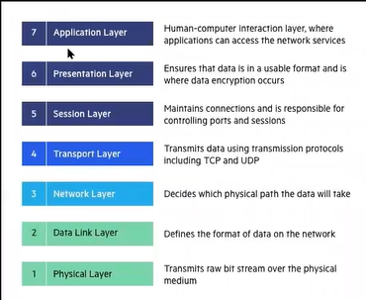

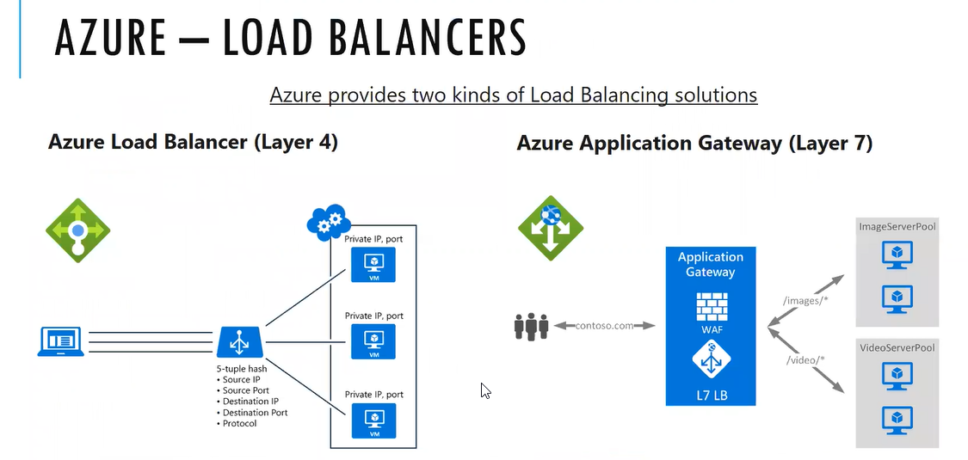

Application gateway is intelligent and used in webapps where as load balancer is not that intelligent it will simply forward the request

All .com will handled by laod balancer from public dns it will resolve and forward/hit to load balancer and it will provsion the particular VM

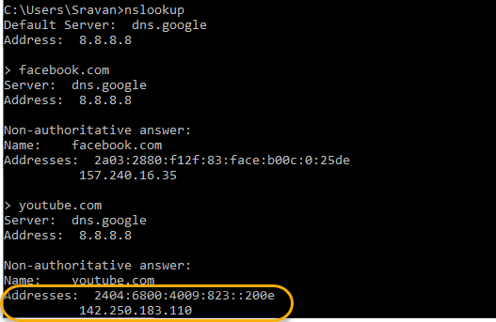

Multiple ips are created for one web application

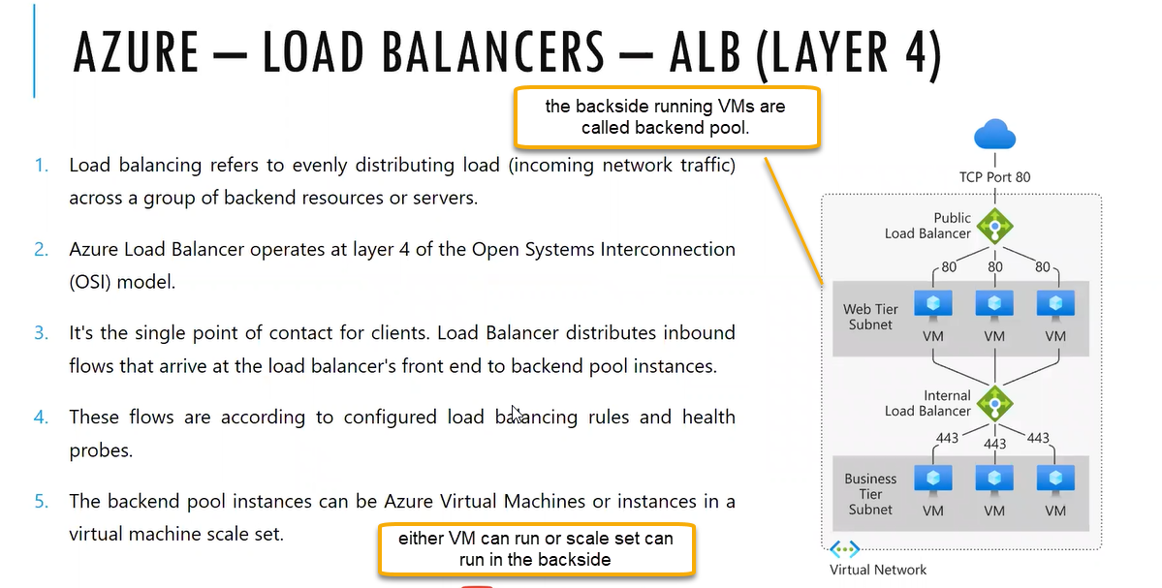

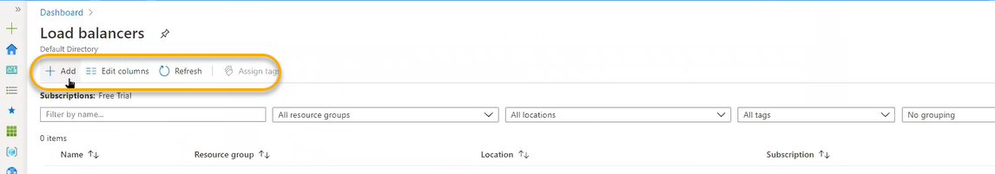

Load balacer can be used in two ways 1. Internal and 2. Public

Internal load balancer is specific to private Ip and it is senstive. Most commonly used is database

Public is specific to public Ip and most commonly used is website

Which type of application we are hosting in backend we define the type

If you select internel public ip option will be vanished and if you select the public the public ip will be appear

Website domain name register in that DNS public IP we will map here

Any one who hit the url from the broswer or domain name the public ip will resolve it will send the request to bacend instances

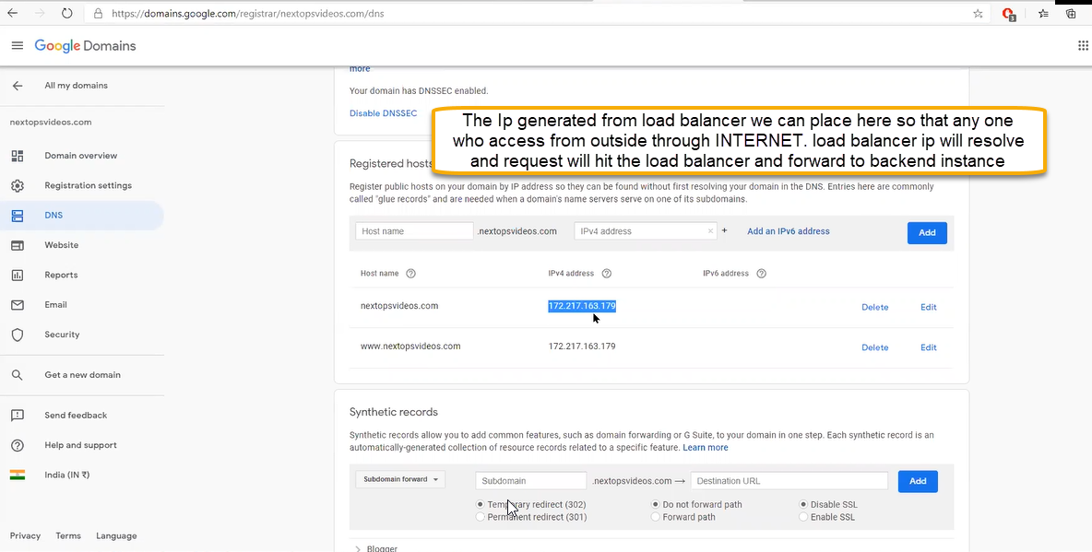

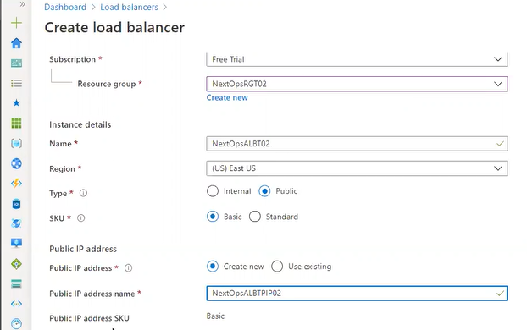

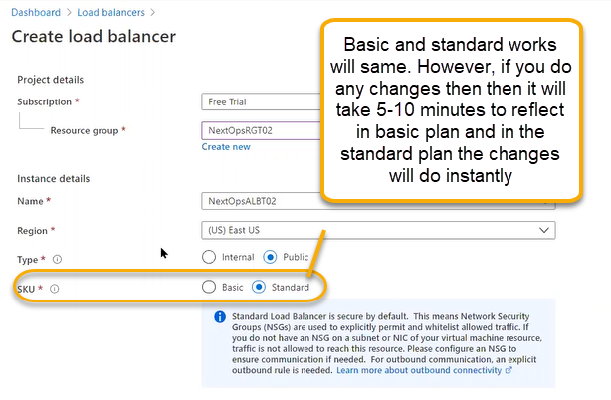

Public Ip: Address SKU ( Standard and Basic)

Basic: If you are reserving an ip address for public we don’t have any protection for tha IP. If you reserve that IP that IP will be completely exposed. If that IP is asosciated with the resource( Load Balancer, VM ) the chance of attacks are more.

Standard: resreves public IP by default access will be block. So we need to give explicity mention to allow the IP by configuring the NSG Rules ( by proving in bound and out bound)

Public IP : Assignment or allocation

Dynmamic: if you reset the load balancer instance/ power ON/Off the VM in that case public Ip will be changed. If the IP changes then the DNS will change then end user cannot acess the website

Static:the IP will be constant across all the time

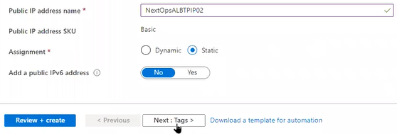

Click on next and Review and create

After the deployment we will see the options for the components to configure

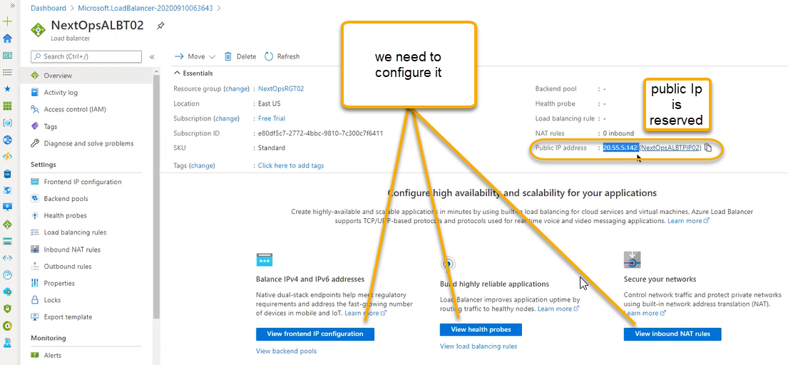

Most common problem: Request will go to load balancer and then it will not forward to backend pool

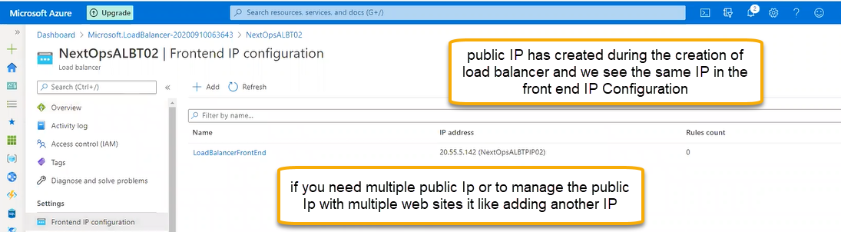

Everytime for frontend IP only one backend pool will associated

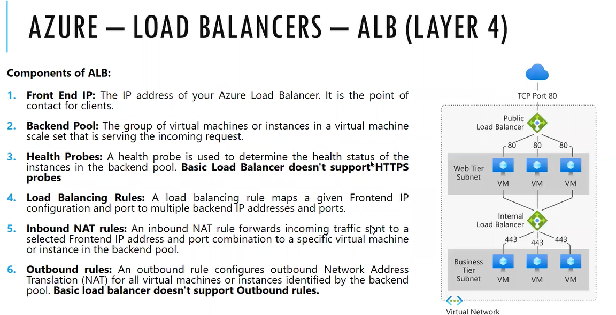

Probing is nothing but ping periodically it will send the request and if we get response then that is a helalthy response

Scale set will do repairs automtically however for the indivudual machines we need login and see the issue

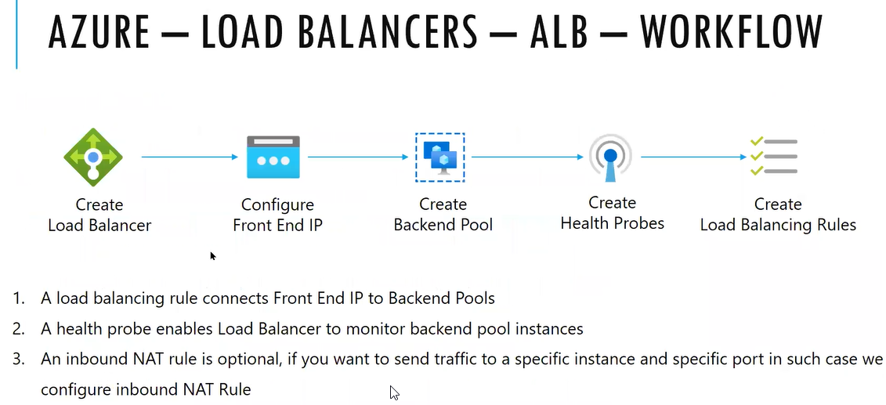

It will support any layer/protocal since it is placed in TCP model. For the backend pools in which we have created VMS does not need to assign the Public IP)

( In two VMS we need to place web server and google browser, ) if you google the local host then defaultly IAAS services will be opened if you install web server

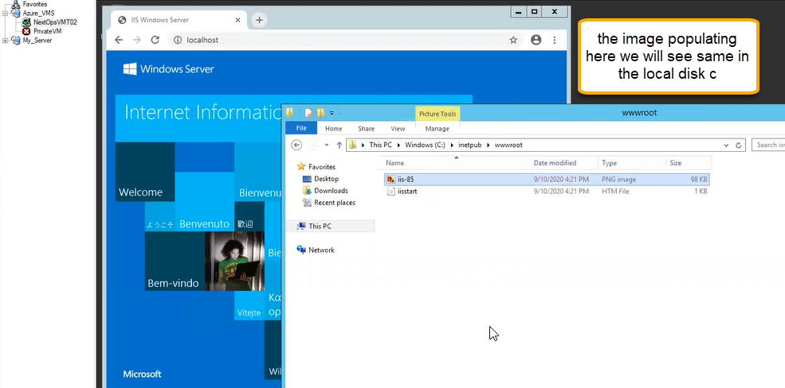

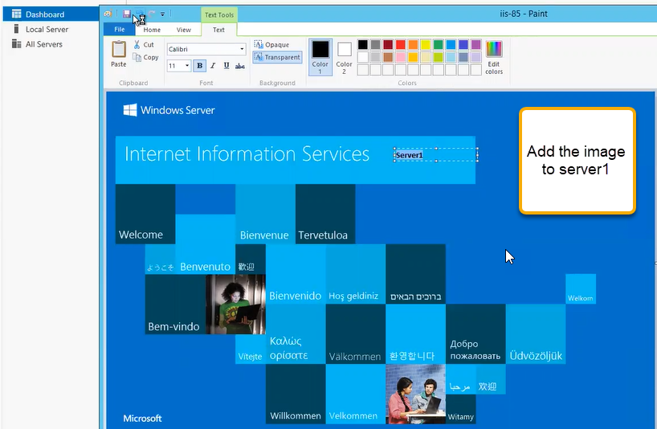

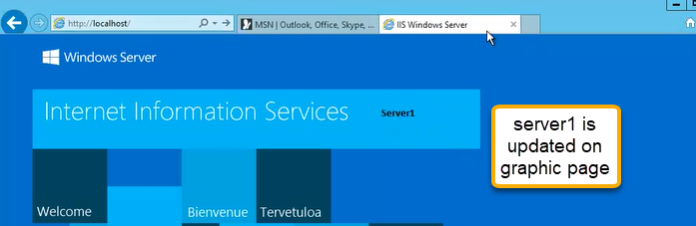

For the first VM we have named as server 1 and the second VM keep it as blank for web server

We need to add the backend pool make sure that if you don’t have public ips associated to VMS

Go to VM> Networking

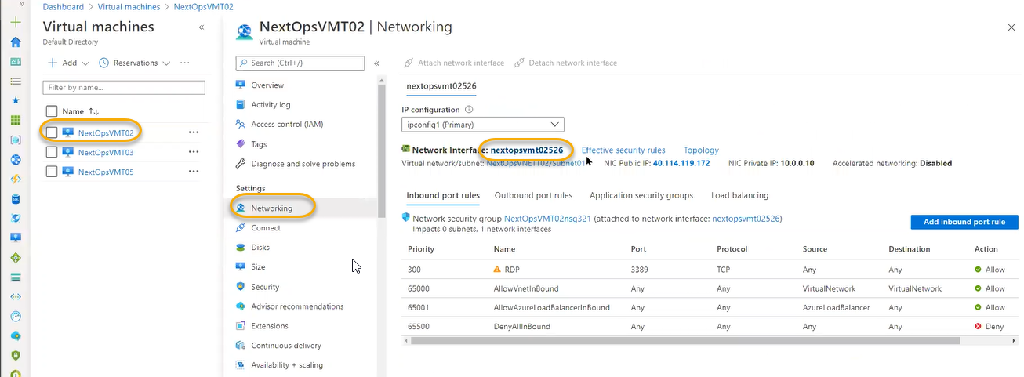

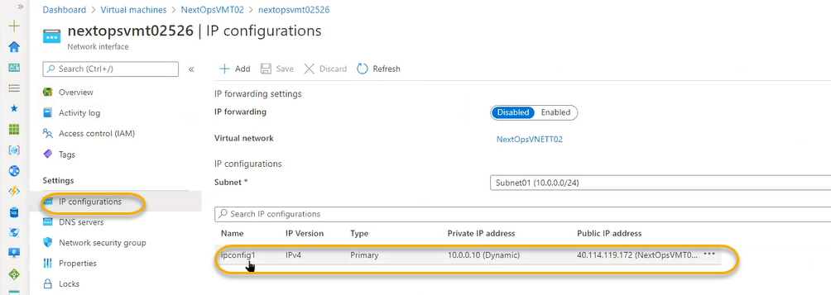

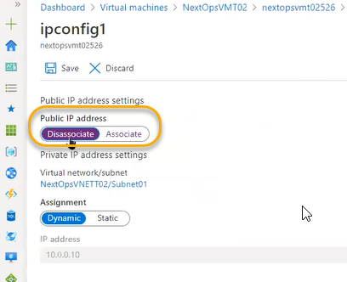

And save it

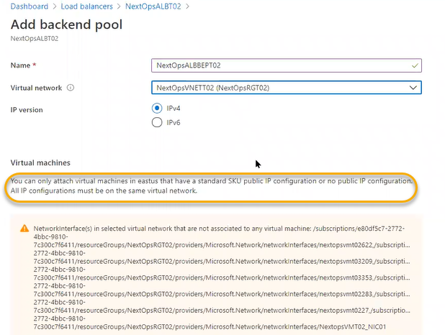

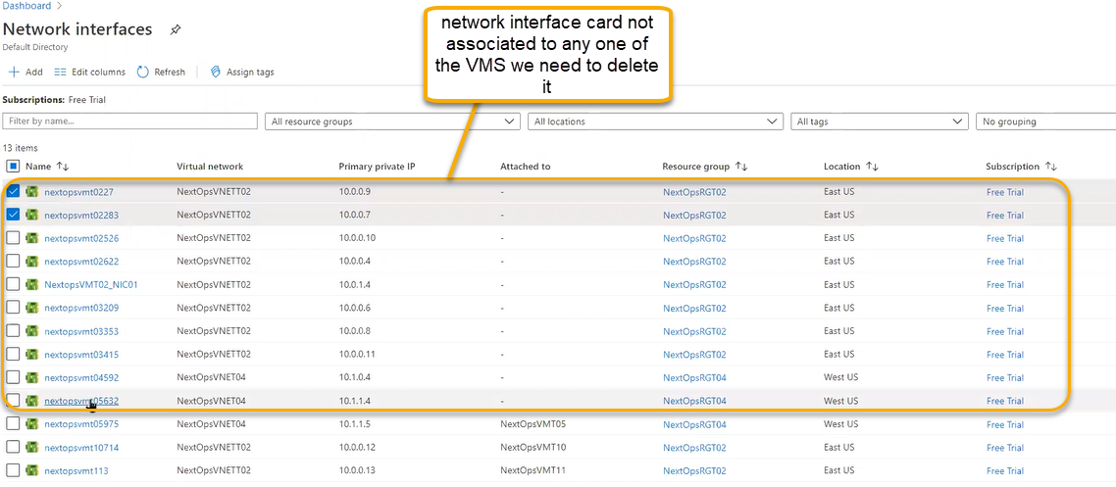

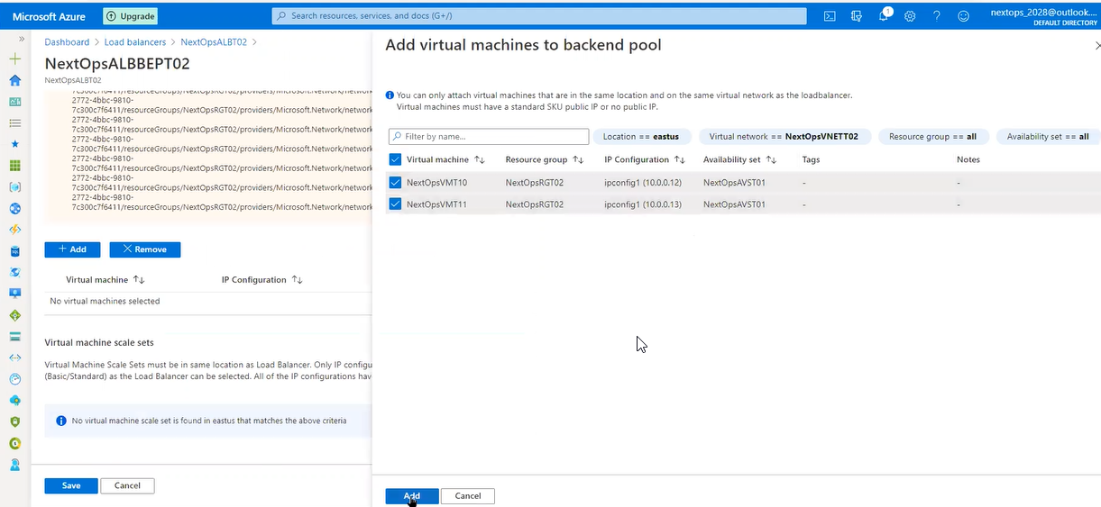

The VMs must be placed in the avaialibilty set which must be in same set and should not associate with the public IP and do not maintain multiple NIC Card

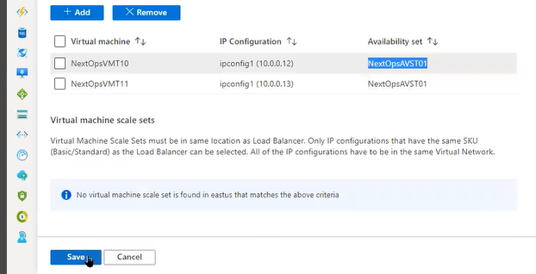

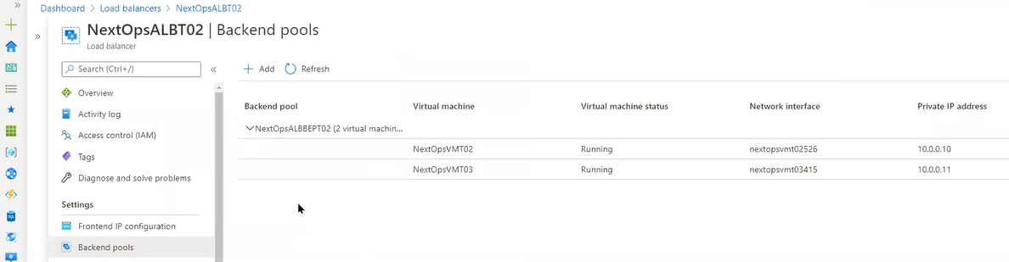

Round Robing Mechanism: Rotate chesthu request send chesthindhi

Health probe: if any one of the machine is down then it does not accept the request we need to identity that machine and load balancer does not want to send request to that machine

Protocal we have three options:

TCP: for Any port we can send the request ping(space) host name

Or if we know the website is running on backend intsance we can use HTTP. In the port 80 they will do directly access the internet.

For every five seconds load balancer try to access the website. If that machine got response from load balancer if it success ful message then that code is 200. Http page not found we see the code as 404. 503 is service unavailable. Based on the codes health probe will check the status of the code

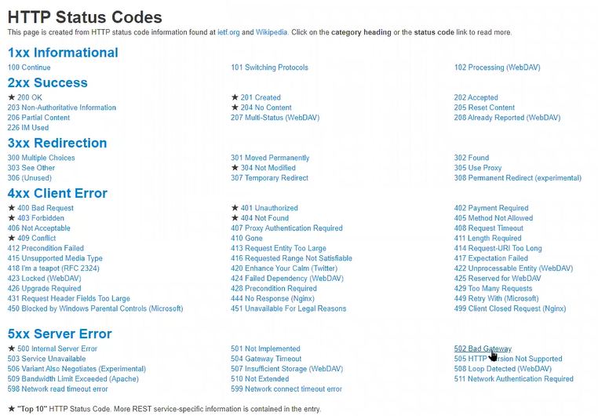

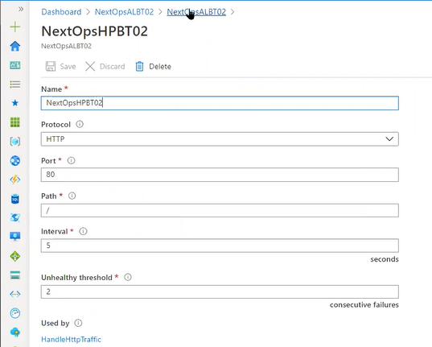

For every 5 seconds ( we can increase the interval upto 60 seconds – 5 minutes) interval the load balancer will ping IF YOU GET 404 Code continuosly for 2 times then that VM Machine is not healthy

Creating the health probe will take 5 minutes in basic plan where as it will take instantly in standard plan

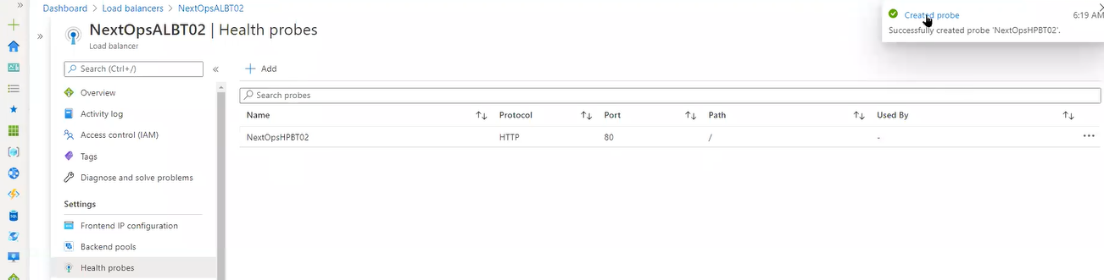

We need to connect the Fronend Ip configurations, Backend pools and health probes(we have configured it indiviually however we need to connect it all three of them)

For that we need load balancing rules

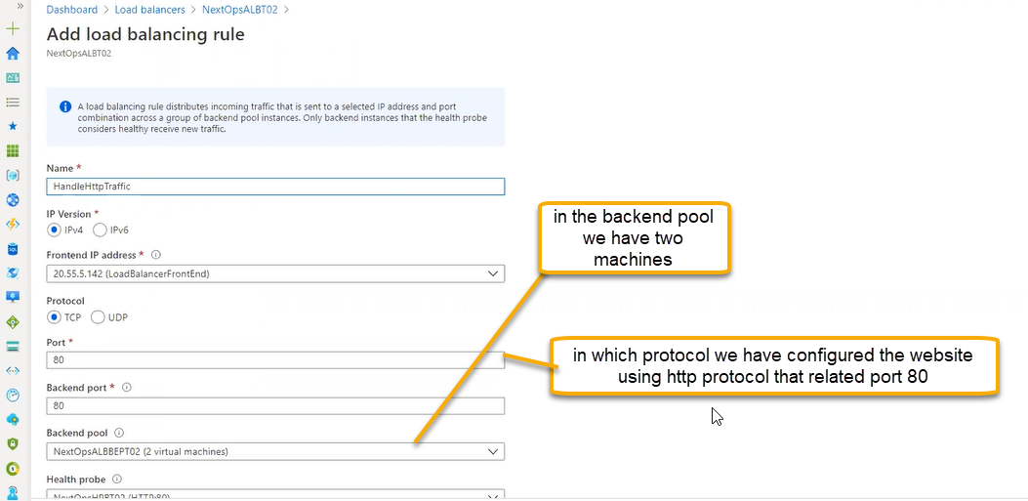

Session persistence: None is the recommended option

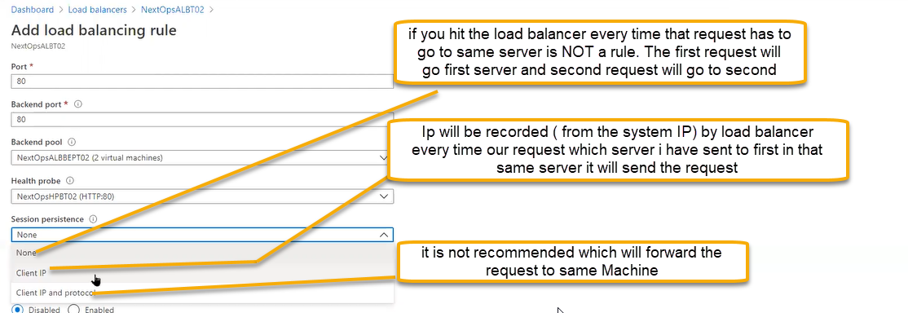

Idle timeout

End user sends the request and when the page does not load (when request will come at what time it should the expected result)

If the page does not load in which in the time mentioned then that page time out



TCP reset

Long running operations we will use it. For example we will open google and we will not use for along time then the opeartions must be reset

Floating IP ( recommended for the sql servers NOT for webs server)

If we have database servers in the backend always there will be clusturing. If you put multiple sql servers in backend pool

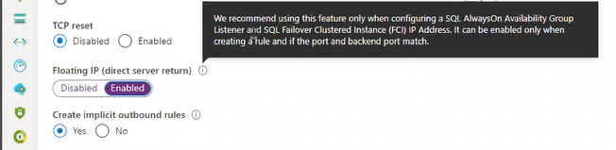

Implicit outbound rules

Incoming ( public IP) will hit transaltion will do and go to the back end pool (response traffic from backend pool we will create the rules for the http we need nating or not )

That rules we wiill not see even though we enabled it.

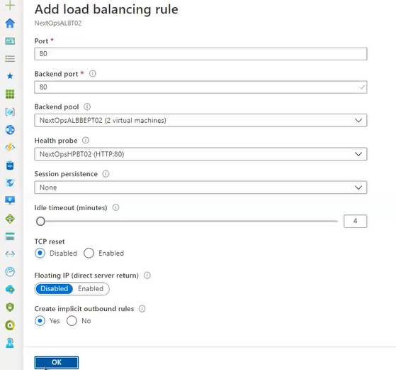

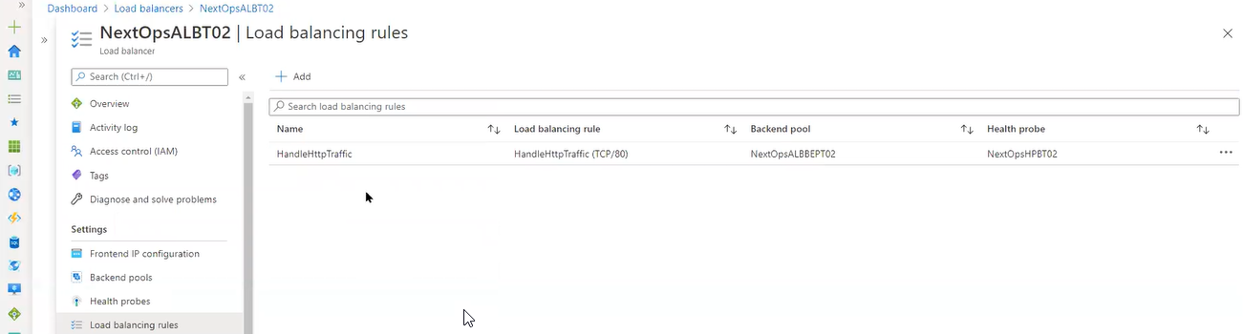

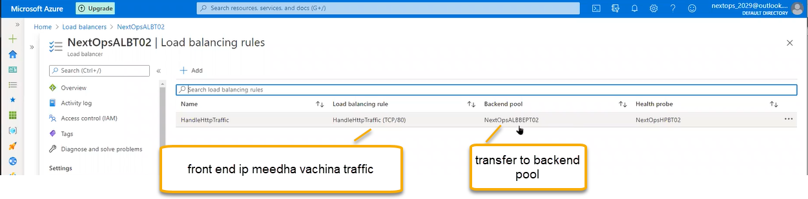

We can assign multiple websites using load balancers for that we need add another front end ip

After that create the inbound rules for VM 1 and VM 2

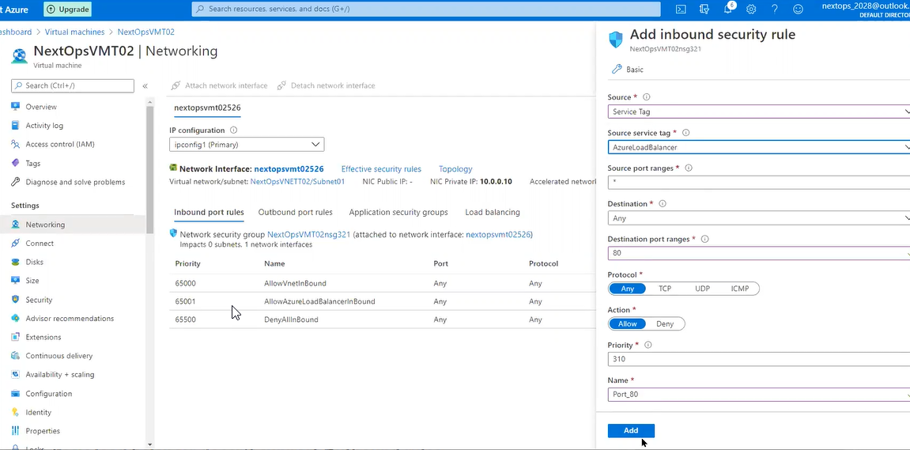

Inbound NAT Rules if you want assign some specific port to particular machine then we can do it frm here

It is same like through firewall we connect to RDP in the same way we need to connect the Inbound

We are connecting 1st instance through RDP and if you hit the public IP it will connect RDP

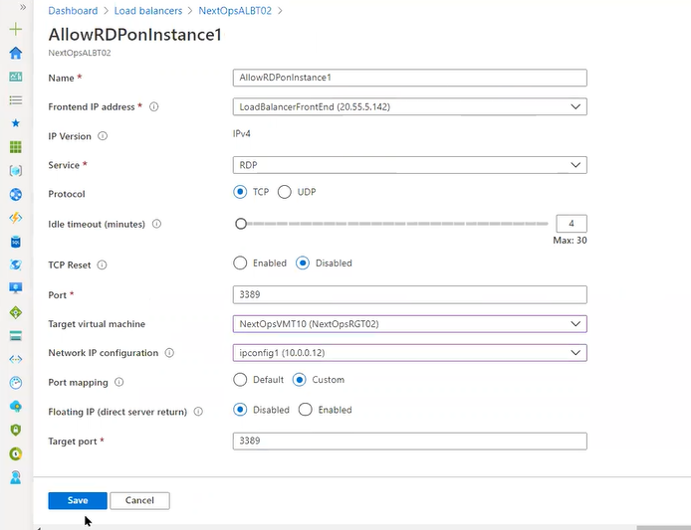

Add the same inbound rules to respective VM

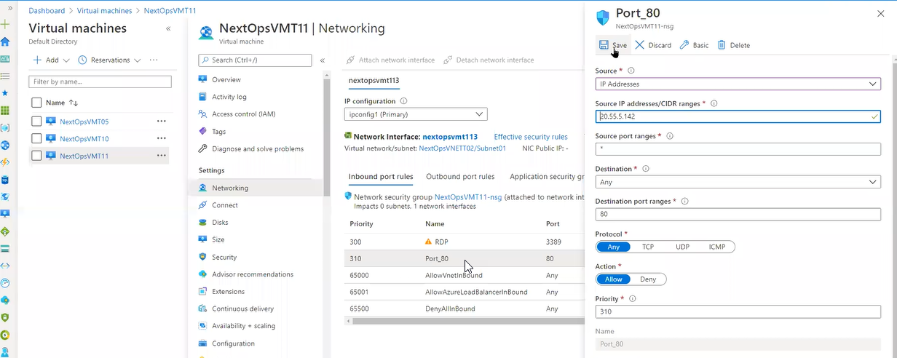

Add the same rules in the VM2

If you hit the public IP via RDP then it has to Open

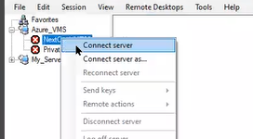

Try to access the webserver via public Ip

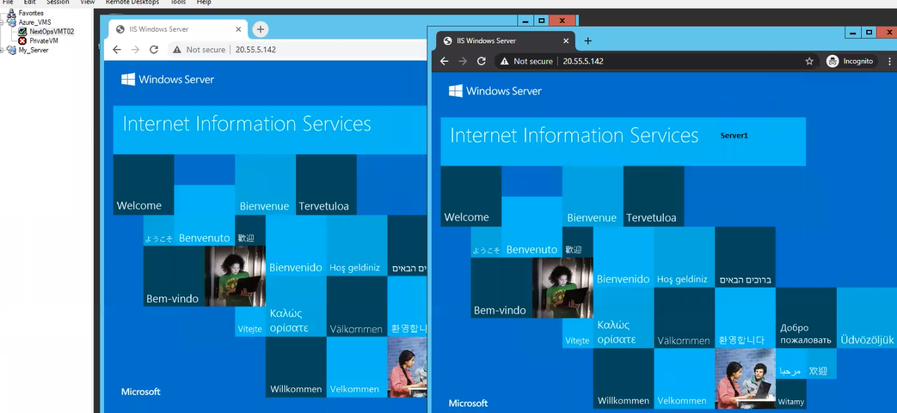

To access the public Ip via browser we need to disable the firewall from windows level or linux level

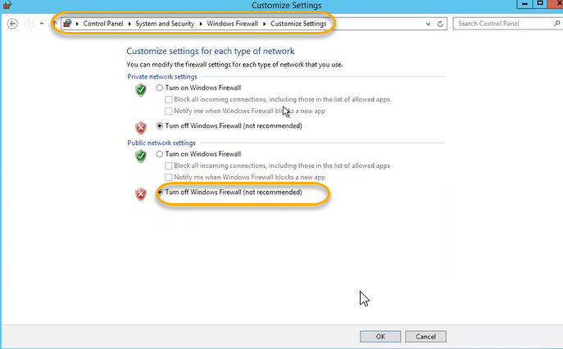

If you want to allow the port eventhough we turn on windows firewall Go to the advance settings

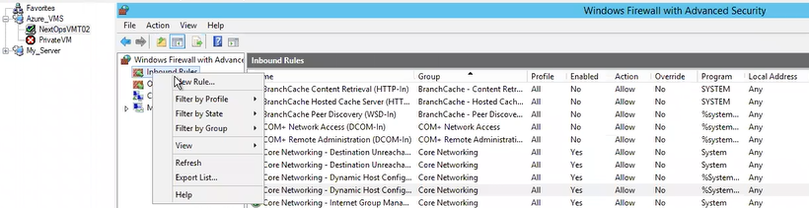

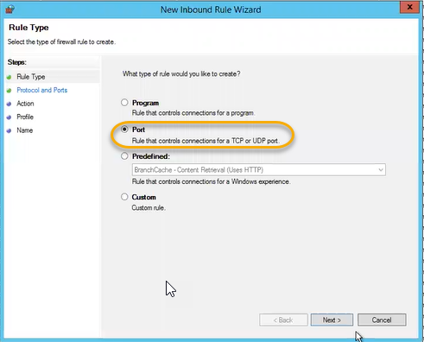

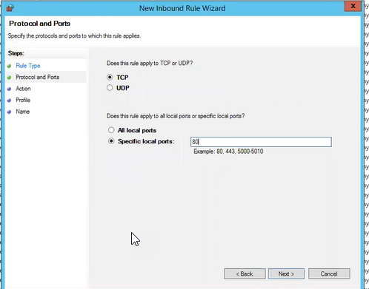

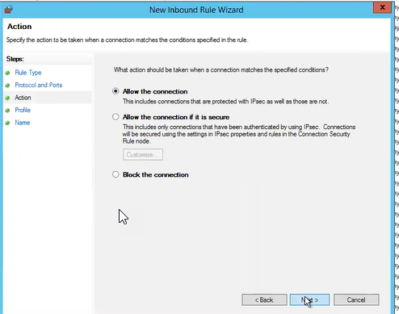

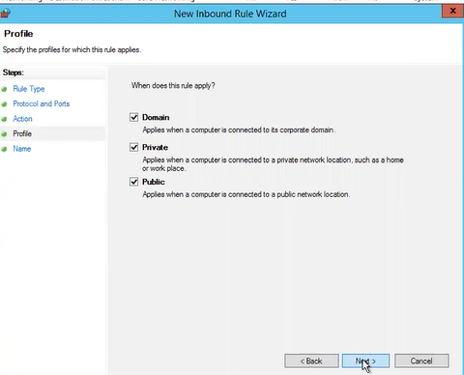

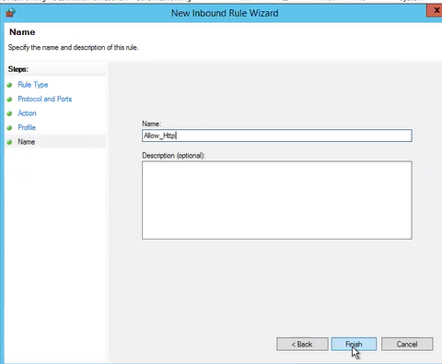

If you hit the public ip from one browser and the same public in another browser at a time then we can see the one web server instance in one browser and second web browser in another broswer

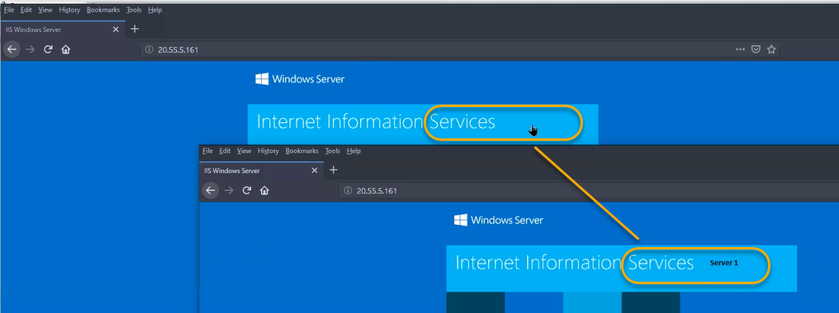

Outbound Rules ( which is same as inbound NAT rules ) If we have already Inbound NAT rules which is associated with Front end IP then we need to create another Front end IP for Outbound Rules

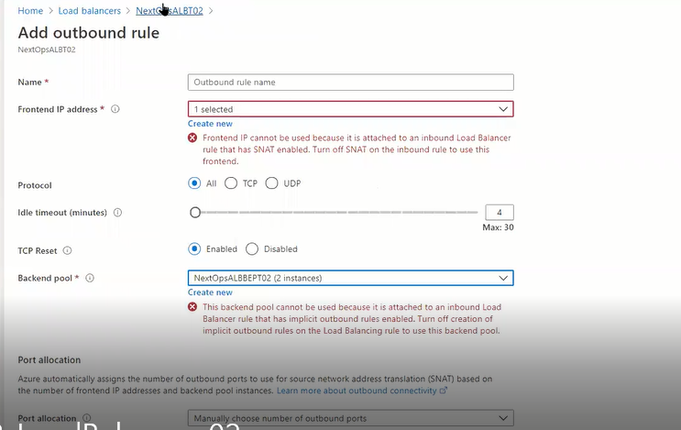

Using the load balancer Ip the instances has to go outside. We cannot use the Inbound public IP to outbound Public IP

We need to configure the second front end IP

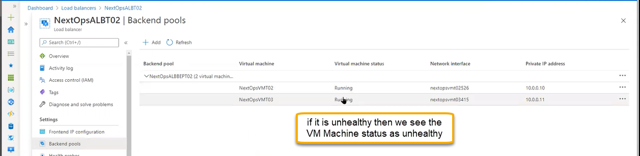

If you want to delete the VM follow the below image

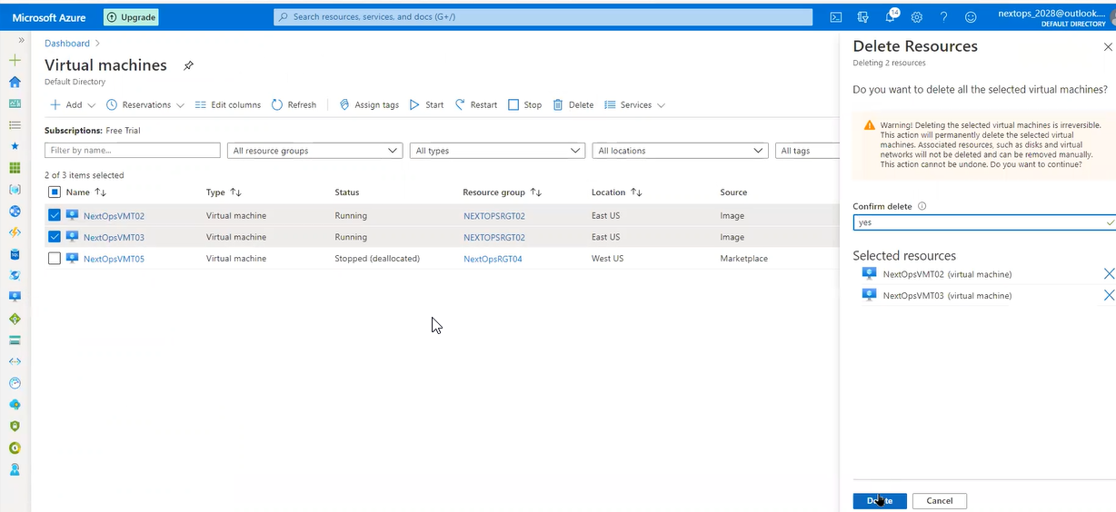

If you are connecting to VM remotly for client network they will not give VPN and have any private IP we can use Run command and execute the script

